Engine Test Document
Checks headings, lists, tables, code, callouts and figures
Sample build
Contents
1 System overview 3
1.1 Boards and addresses 3
1.1.1 Rules 3

1 System overview
The Jet Ranger panel is driven by one PC over Ethernet. This paragraph checks italic, bold, and inline code such as D,PITCH:4.5,BANK:-12.0.
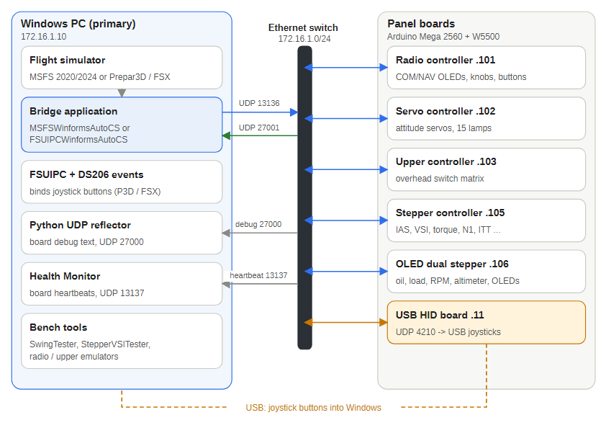
Figure 1 — The whole system on one page

1.1 Boards and addresses
Board | IP | Role
Radio controller | 172.16.1.101 | COM/NAV displays, knobs, buttons
Servo controller | 172.16.1.102 | attitude servos, lamps
Stepper controller | 172.16.1.105 | seven gauges

1.1.1 Rules
- Gauges are powered from the main bus at 20 V or more.
- The Radio uses the avionics bus at 24 V or more:
  - if the avionics bus reads 0 the main bus is used
  - otherwise it uses the avionics bus
- Everything else follows.
- First step.
- Second step with code.
- Third step.
Note: callouts are used for cautions and tips.
D,PITCH:4.5,BANK:-12.0,EOUT:0
C,RESET:1

